Lincoln Cathedral Library Exhibition
September – October 2017
Biblia Pars 1 “The Lincoln Chapter Bible” (11th century) Lincoln Cathedral Library, MS 1
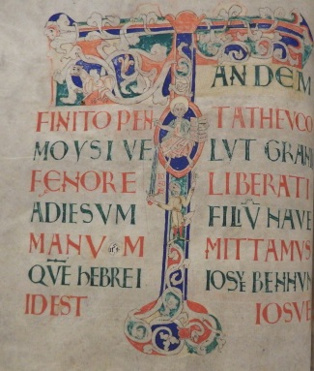
Lincoln Cathedral’s Chapter Bible has international significance as the earliest English illustrated Bible of the Romanesque period. It was commissioned by Nicholas, Archdeacon of Huntingdon, and is one of a handful of books known to have been written locally.

Augustinus super psalmos (12th century, before 1148) Lincoln Cathedral Library, MS 155
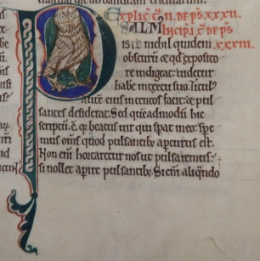
This manuscript, Augustine’s explanation of the Psalms, is listed in the first catalogue of the Cathedral’s books and has therefore been at the Cathedral for almost 870 years. It is one of the manuscripts believed to have been written in Lincoln.

Haimo in Epistolas Pauli (12th century, before 1156) Lincoln Cathedral Library, MS 171
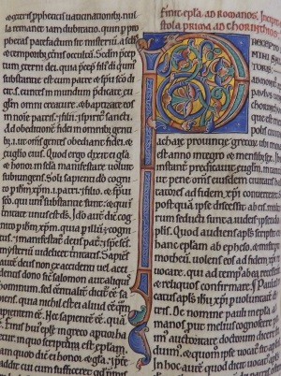
This volume of commentaries on the letters of Paul was given to the Cathedral in the middle of the 12th century by Jordan, Treasurer of Lincoln between 1146 and 1156. How do we know this? We know who gave us this manuscript because it is listed in the 12th century catalogue of the Cathedral’s books, where the name of the donor is also given.

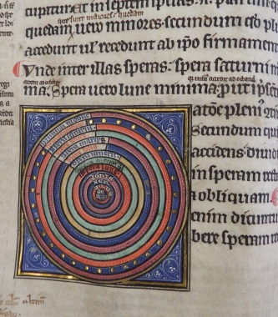
Manuscript of Iohannes de Sacrobosco (13th century) Lincoln Cathedral Library, MS 148
Although known to have been owned by Master Richard Sutton in the 14th century and John Remchinge in the 16th century, this book was actually given to the Cathedral in the 17th century by Dean Michael Honywood. It contains, amongst other things, Sacrobosco’s most famous work “De sphaera” in which he describes the heavens and the Earth as a sphere. It was a set text for Western students for almost 400 years.

Charles II, King of England. Act of Uniformity, 1662
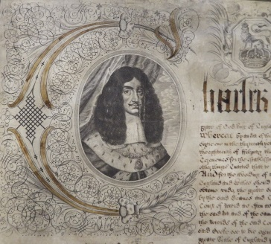
The 1662 Act of Uniformity was brought into force after the Restoration of the Monarchy and was a way of establishing some sort of religious common practice throughout the Church of England. All Cathedrals and Churches were required to keep a copy of the Book of Common Prayer printed in 1662 and to follow the format for prayers and services as laid down in it.

The Book of Common Prayer…Together with the Psalter Printed in London, 1662
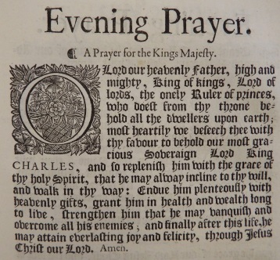
The Book of Common Prayer is not simply a collection of prayers but also contains the forms of service for daily worship, ordinations and other religious ceremonies such as baptisms, marriages and funerals. It reinstated ceremonies that had been abolished by the Puritans during the English Civil War. Included are prayers for the Royal family. Each time there is a new monarch, a new Book of Common Prayer has to be published.

Milton, John. Paradise Lost Printed in London, 1667
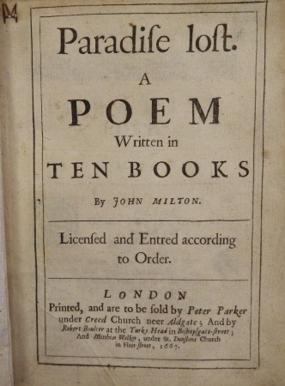
The poet John Milton (1608-1674) was a younger contemporary of Michael Honywood at Christ’s College, Cambridge. It is not surprising therefore, that Honywood owned several of Milton’s works, including this first edition of his epic poem on the Fall of Man, “Paradise Lost.” The first edition consisted of 10 books with over 10,000 lines of verse.

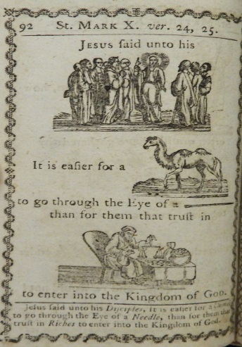
A curious hieroglyphick Bible or select passages in the Old and New Testaments presented with emblematical figures for the amusement of youth….Printed in London, 1796

Those of us of a certain age may remember books like this from our childhood, where nouns were replaced with pictures in order to make the books more interesting and easier to read. This must have been a very popular book, as this is the 13th edition since it was first published 13 years earlier in 1783.
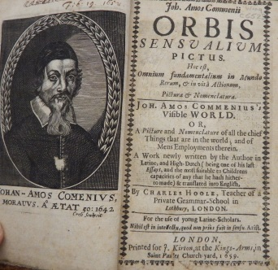
Comenius, Joannes Amos. Orbis sensualium pictus Printed in London, 1659
Otherwise known as Commenius’s Visible World, this little school book claims to include pictures of and the names of “all the chief things that are in the world, and of Mens employments therein” as a means of teaching children Latin. It is thought to be the first children’s picture book. Originally published in 1658 in Latin and German, it was translated into English by Charles Hoole.

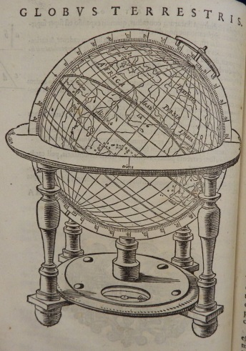
Hues, Robertus. Tractatus de globis, coelesti et terrestri. Printed in Amsterdam, 1617

Written in Latin, this book looks at all aspects of celestial and terrestrial globes. It was written by Robert Hues, an English mathematician and geographer, who had studied navigation at a school set up by Sir Walter Raleigh. His “Treatise on globes, celestial and terrestrial and their use” was first printed in 1593. This 1617 edition is the 6th printing “now enlarged by elegant pictures and drawings”.

Mercator, Gerardus. Atlas novus sive descriptio geographica totius orbis terrarum. Printed in Amsterdam, 1638
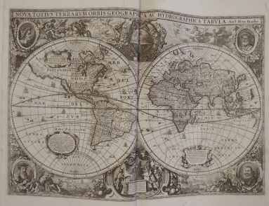
The Cathedral library is fortunate to possess several early atlases, including this example by the renowned Flemish cartographer, Mercator (1512-1594). Mercator was one of the founders of the Flemish School of Cartography. This copy was owned by Michael Honywood, the library’s greatest benefactor.

