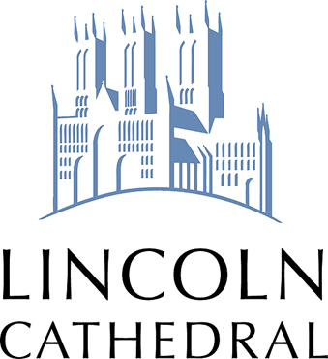
BOOKING FORM

School Information:

School/College
Address
Phone No.
(including mobile, where possible)
Contact Person
Contact Email Address

Visit/Tour Information:

Date
Time | Arrival:  Departure:
Named contact
(including telephone number for the day)
Number of Children
Number of Teachers/Accompanying Adults

Age of Children
Additional Requirements (e.g. SEN)

Please select your desired option for either a guided tour or a self-guided trail.
For more information about these options, please see our website.
Guided Tour: please choose one option
General Children’s Tour (KS1-KS5) |  | Signs and Symbols Tour (KS1-KS3) |  | Magna Carta Tour (KS3-KS5)
Self-Guided Trail: please choose one option (please bring clipboards and pencils/pens with you)
Cathedral Explorer Pack (KS1-KS2) |  | Numbers, Shapes and Patterns Trail (EYFS-KS1) |  | Materials Trail (KS1)
General Children’s Trail (KS1-KS2) |  | Signs and Symbols Trail (KS1-KS3) |  | Magna Carta Trail (KS3-KS5)

Lunch Facility (when available / must be booked in advance):

Area | Time required | No. of children | Extra Information
Medieval Bishops Palace |  |  | Must be booked at least two weeks in advance. Short walk from the Cathedral.
Bag/Lunchbox storage |  |  | Storage in the Cathedral Centre  Subject to availability. £5.00 per class

Admission Charge
Child/Student (18 and under) £1.00 each. (Accompanying Adults free.)
Method of Payment
Please Note:
All numbers to be confirmed one week in advance and charges will be made against these numbers

Payment in advance: Yes/No

Payment on arrival: Yes/No Please pay at reception desk.

Invoice after visit Yes/No Please book in at reception desk and sign invoice.

Please make cheques payable to: Lincoln Cathedral

Declaration

- All of the above information, to the best of my knowledge, is correct.
- We will provide confirmation of numbers one week in advance of the visit and are aware that failure to do so will lead to the school being charged against the numbers stated above.
- 48 hours’ notice is required for cancellation of an organized guided tour. Failure to do so will result in full payment from the above school
- We have read and agree to adhere with the terms and conditions
- We have read the Essential Information page

Name: Position:

Signature: Date:

Your Details
We keep a database of groups who enquire about visits, and write from time to time to inform organisers of news, events etc. Details are not passed on to any other party.

Would you like your details to be kept by us Yes/No

Please Return Form To:

By email to: visitors@lincolncathedral.com or by post to: Visitor Services Office
Lincoln Cathedral
Minster Yard, Lincoln LN2 1PX

PLEASE NOTE
While the Cathedral makes every effort to honour all bookings, unforeseen circumstances may lead to our having to cancel or postpone visits at short notice. We will make every effort to keep disruption to a minimum.

