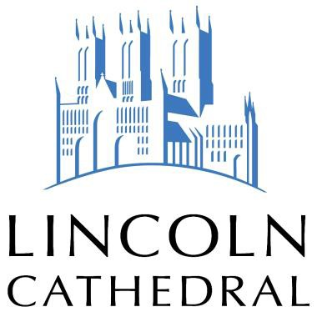

APPRENTICE STONEMASON
INFORMATION DOCUMENT

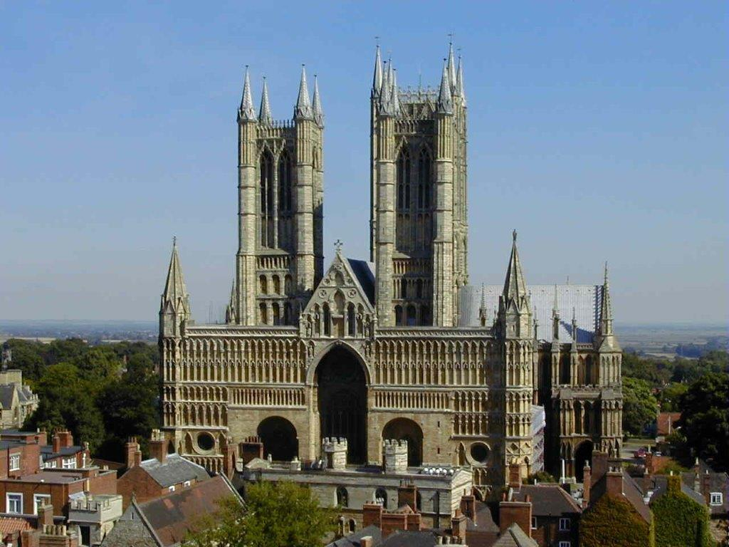

Overview

John Ruskin, the great Victorian art historian and critic, described Lincoln as “the most precious piece of architecture in the British Isles and roughly speaking worth two of any other Cathedrals we have”

The Cathedral Church of the Blessed Virgin Mary of Lincoln (to give it its proper title) is first and foremost a church, the seat of the Bishop of Lincoln and a centre of worship and mission. A minimum of three services takes place each day of the year, at least one of which is usually sung by the Cathedral’s renowned choir. It is the principal church of Lincolnshire and holds many of the county-wide services of celebration, commemoration and memorial.

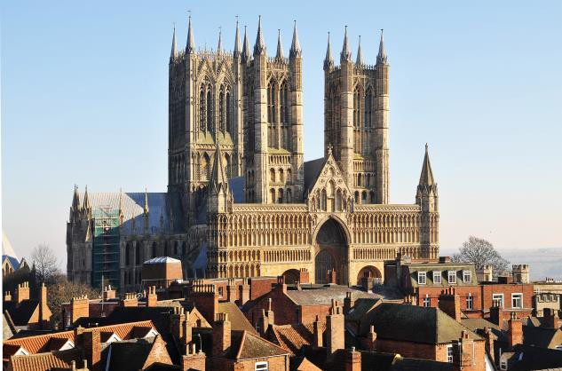
There is a real richness and variety in the way the Cathedral building is used.
Significant musical, dramatic events take place, whether it is a visit from the Halle Orchestra; a performance of the 70’s musical Jesus Christ Superstar; Mystery Plays; or international pop musician Ian Anderson, of Jethro Tull fame, coming to perform. Also there is an active lecture series each year with key speakers offering their insight into current and historical
affairs. West View of Lincoln Cathedral. ©Lincoln Cathedral
Lincoln Cathedral is a place of pilgrimage, where people come to seek God, to learn more about faith, or to take time out of a busy day for quiet reflection. It is a place of welcome and hospitality where all of any faith or no faith are encouraged to feel at home.

Last but not least Lincoln Cathedral welcomes over 200,000 visitors a year who come to marvel at and enjoy a Cathedral that represents the highest achievements in medieval engineering, craft and design. Today skilled craftspeople and conservators, employed by the Cathedral, strive for excellence in everything that they do to and for the building; leaving their own legacy for those who follow.

A Brief History

After the Battle of Hastings in 1066 William the Conqueror established a castle in the south- west corner of the old Roman city of Lincoln (Lindum Colonia). One of his supporters, Remigius Bishop of Dorchester, was instructed to transfer his cathedral to Lincoln in order to consolidate Norman power in the north. Construction commenced in 1072 and the building was consecrated as a Cathedral in May 1092, two days after Bishop Remigius’ death.

Before long the country was plunged into civil war again as King Stephen and Empress Mathilda fought for seventeen years for control and in this period, probably around 1141 the Cathedral was damaged by fire and a partial rebuilding was ordered by Alexander the Magnificent (Bishop of Lincoln 1123-1148). Disaster struck again and in 1185 an earthquake destroyed all but the West Front and its twin towers. Hugh of Avalon arrived in 1186 and he set about fundraising for a rebuilding which began in in 1192.
Hugh died in 1200 before the great transept and Nave were finished, and was buried in his Cathedral. Miracles were experienced by those who came to pray at his tomb, and in the space of 20 years he was proclaimed a saint by the Pope. By 1255 the numbers coming on pilgrimage to his tomb were so great that it was decided that an extension at the east end should be built.

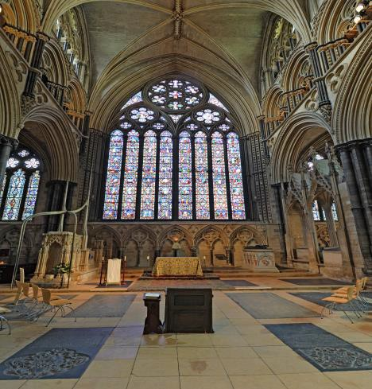
Hugh’s body was transferred to the new “Angel Choir” in 1280 and pilgrims continued to come, paying for further beautification of the building so that between 1307 and 1311 the central tower was raised to its present height, and later that same century the two western towers were heightened. Wooden spires covered with lead were added so that for two hundred years Lincoln Cathedral was the tallest building in the world. Alas, in 1548 the spires on the central tower collapsed.

East End and East End Window. © Lincoln Cathedral

The Reformation brought great changes to Lincoln and between 1540 and 1548 the chantry chapels were dissolved, St. Hugh’s body was removed, the shrine was stripped of its jewels and the treasury of its contents and the content of the daily services was vastly simplified.
However the greatest threat was posed by the English Civil war one hundred years later when the Cathedral Close was besieged in May 1643 and the Cathedral pillaged. The round of daily services was abandoned and the building fell increasingly into disrepair.

The restoration of the monarchy in 1660 saw the appointment of Dean Michael Honywood. He was a deeply cultured and scholarly priest whose concern for the dignified worship of God led to a revival in both liturgy and fabric. He paid for repairs to the building, built the Wren Library, made new appointments to the choir and ensured that the revised Book of Common Prayer was in use from 1662.

By 1726 the weight of the western towers and spires were causing them to lean and in 1729 the architect James Gibbs added cross walls for strengthening. The western spires were finally removed in 1807 for safety reasons resulting in the Cathedral we see today.

The challenge of raising funds to maintain this great building is with us today. Lincoln Cathedral sits on Historic England’s (formerly English Heritage) risk register as it is recognised that the Chapter needs to raise £1.6million per annum to maintain the schedule of repairs required. A dedicated team of people, clergy, lay and volunteer alike all work together towards this common goal.

Lincoln Cathedral Connected

Lincoln Cathedral Connected is an exciting £16 million project which will transform the Cathedral’s visitor facilities, grounds and internationally important architecture. It will achieve this by engaging a wide range of people with the stories of this magnificent building. It is envisaged that the project will complement Lincoln Castle Revealed, helping to put Lincoln on the visitor map and boosting the profile of the city.

Works Department

One of the stated aims and objectives of Lincoln Cathedral is to care for the fabric of the Cathedral, to allow it to speak boldly and imaginatively by careful planned maintenance of the building now and into the future and to develop and share craft skills at home and abroad.

This objective is fulfilled by the members of the Works Department, wholly employed by Lincoln Cathedral. The works team consists of: Stonemasons; Conservators; Glaziers; Carpenter/Joiners; Leadworkers; Domus (Engineering and Maintenance). The Department has its own Archivist and is supported by a small office team.

Within the curtilage of Lincoln Cathedral there are around 80 tenanted historic properties and associated buildings all of which fall under the care and maintenance of the Cathedral Chapter and its Works Department

Stonemasonry and Conservation

Stonemasonry and stone conservation are the largest elements of the works programme. We currently have a total of sixteen masons and stone conservators.

The main focus of our masonry work at present is the Lincoln Cathedral Connected project . We are in the early stages of a five-year conservation project. This project is running in tandem with our ongoing work on the Cathedral and the Close House properties

Based on the recommendation of the Cathedral Architect’s Quinquennial report and the programme agreed by the Cathedral Chapter, there will be a full programme of masonry and conservation work for the next two decades.

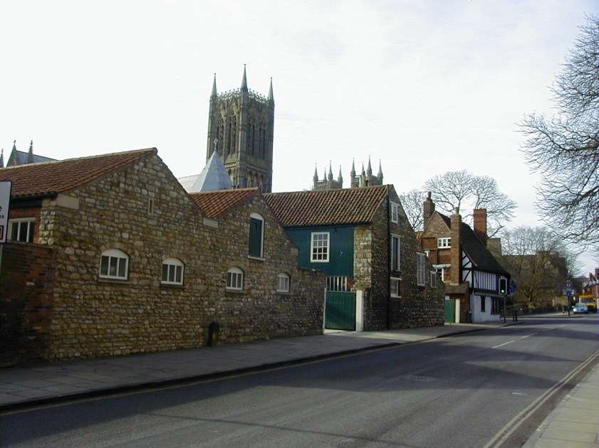
JOB TITLE: APPRENTICE STONEMASON

MAIN PARTICULARS OF THE POST
Salary: Meets apprenticeship National Minimum Wage requirements
Contract: Fixed Term for 3 years
Pension: All eligible employees will be automatically enrolled in the Pension Builder 2014 section of the Church Workers Pension Scheme operated by the Church of England Pensions Board.

Working hours: 38.75 hours per week. Your normal hours of work are from 8.00 to 16.30 Monday to Thursday and from 8.00 to 15.30 on Friday with an unpaid meal break of 30 minutes each day, to be taken between 12.30 and 13.00 or flexibly subject to the requirements of the job

Holidays: 33 days per annum including 8 Bank and Public holidays. 3 days must be held for the period between Christmas and New Year.

APPLICATION PROCESS
Please submit your application using the Cathedral Works Department application form. A CV is not an acceptable substitute but may be attached as an additional document if you wish.

INTERVIEW AND SELECTION PROCESS

Closing date for applications: Midnight Friday 1st June 2018

Interview date: Thursday 14th June 2018

Applications by post or email to

Miss A Parker

Human Resources Administrator

The Chapter Office

4 Priorygate

Lincoln

LN2 1PL

email: HRadmin@lincolncathedral.com

