Lincoln cathedral
Accessibility guide 2023
Welcome
Welcome to Lincoln Cathedral; a place of worship and pilgrimage for 950 years. Services still take place every day and we are open 363 days a year for visitors to experience this beautiful historic building, and we hope that you take away wonderful memories of your time in Lincoln.
The cathedral’s ground floor footprint (with the exception of smaller chapels) is fully accessible for wheelchair users, and we do all we can to cater for specific access requirements.
Should you require further information or additional assistance, please contact us so that we may help you to plan your visit.
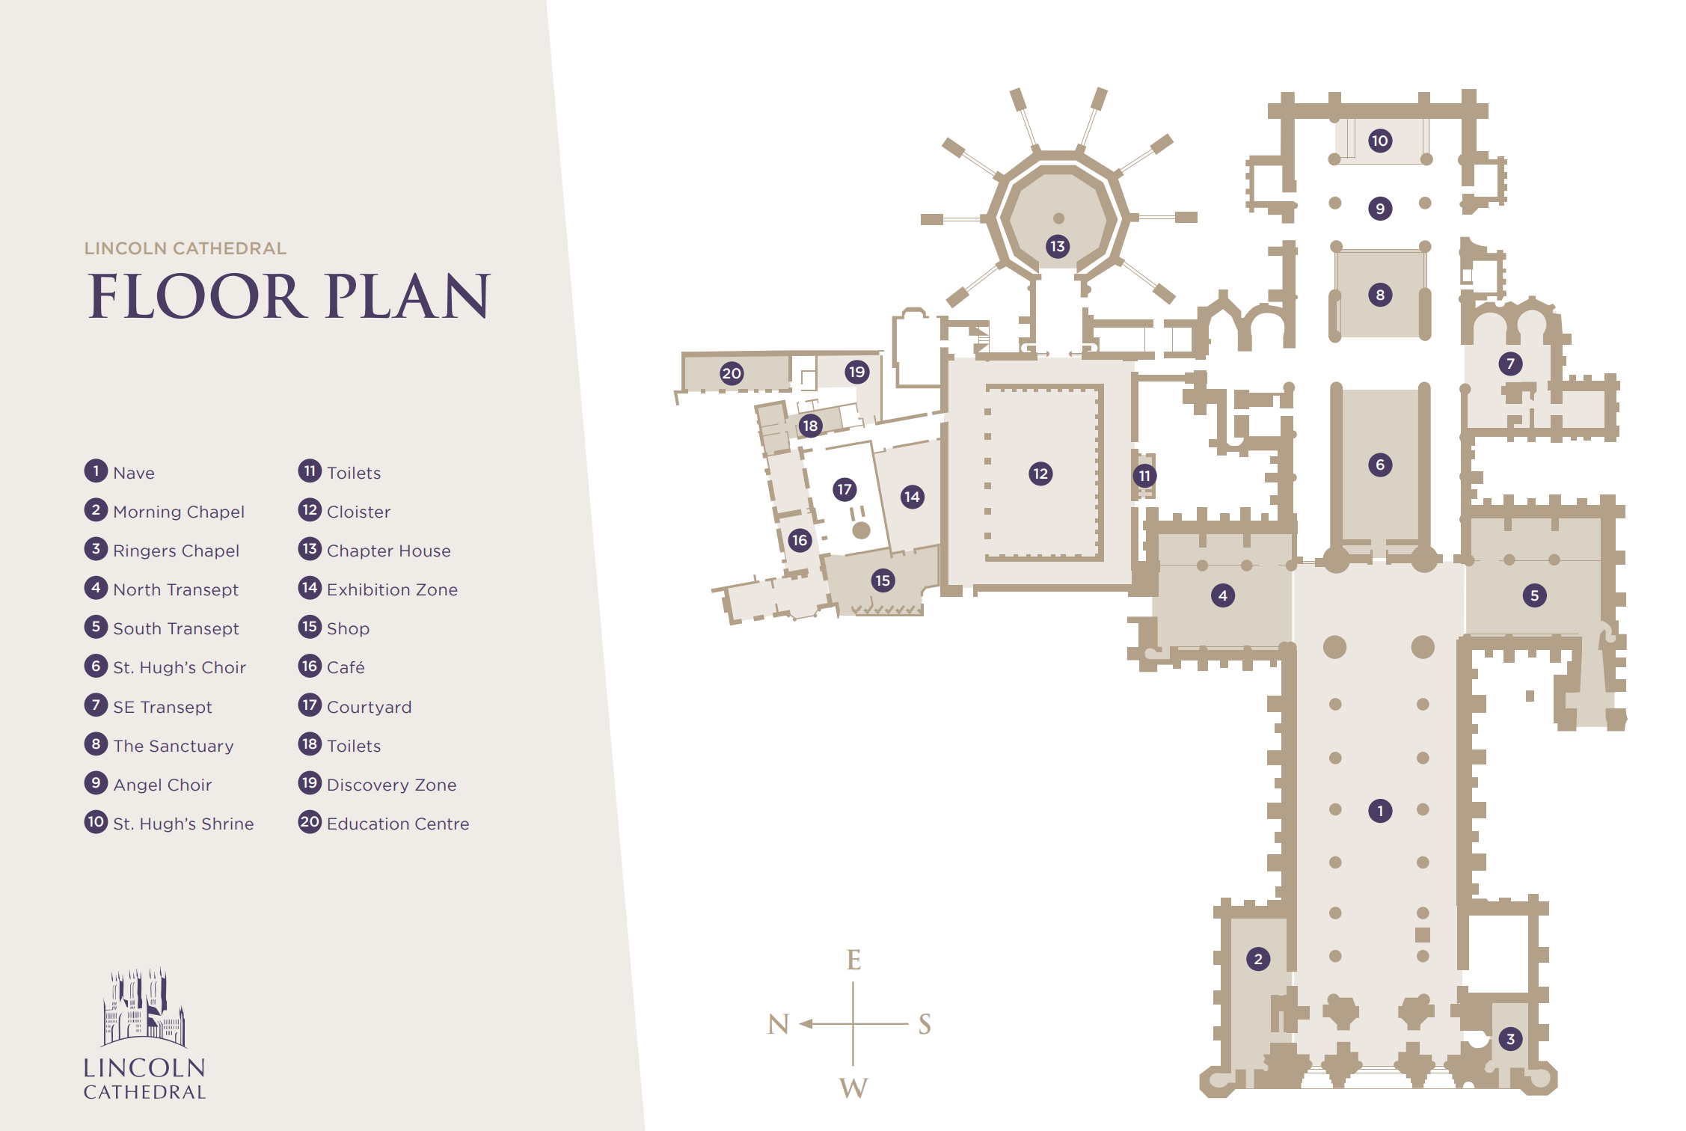
Lincoln Cathedral at a glance
Level access
There is level access from minster yard (ln2 1px) into the cathedral via the main entrance. The cathedral’s visitor centre also has step-free access into the shop and café.
The main cathedral floor is step-free except for some small chapels. There is a platform lift to provide access from the cathedral to the visitor centre. There are four lifts available in the visitor centre to provide access from the roadside into the building and to the first floor.
Hearing
- A hearing loop is available at the welcome desk, shop and in the community rooms

Visual
- Glass doors have contrast markings
- Orders of service are available in large print
- Carvings may be touched
- Welcome leaflet is available in large print
- Café menus are available in large print
General
- Carers and companions enjoy free admission to the cathedral and to cathedral-run events
- Staff have undertaken disability and inclusivity awareness training
- Some staff and volunteers have enhanced training in areas such as age, autism and dementia awareness
Assistance dogs
Lincoln cathedral is a dog-friendly site
Assistance dogs are permitted throughout the site
Water is available in the visitor centre
Quiet area
Should you require a quiet area, please speak to a member of staff who will be able to provide access to a chapel

Travelling to Lincoln Cathedral
Lincoln Cathedral
Minster Yard
Lincoln
LN2 1PX
01522 561600
Travelling by train
The nearest train station is Lincoln Central, located 0.9miles from Lincoln Cathedral. The station is operated by East Midland Trains.
The station is fully accessible for wheelchair users with ramps for train access and lifts between platforms.
There are visual and audible announcements at the station.
All taxis at Lincoln Central are wheelchair accessible.

Travelling by taxi
Lincoln has several taxi operators within the city.
To guarantee availability of accessible vehicles, pre-booking is essential.
Handsome cabs - 01522 545352
Marks passenger services – 01522 793 816
https://markstg.com/passenger-transport-lincolnshire/

Travelling by public transport
Most stagecoach buses and all pc coach buses are wheelchair accessible and operate throughout the city centre.
The park & ride service is also accessible, and. Runs Monday to Saturday from 7am to 6.20pm (8am on Saturdays).
The Lincoln open-top tour bus is accessible and runs March to October. The tour bus operates a live audible commentary.
Both the park & ride and tour bus stop outside the cathedral.

Car parking
Lincoln City Council car parks allow all blue badge holders one additional free hour parking for every hour purchased.
There are several on-street zones for blue badge holders around the city and cathedral quarter.
The nearest car park to the cathedral with accessible spaces is:

- Westgate 1 & 3 - ln1 3bg

There are many other accessible car parks in Lincoln. Please visit the Lincoln City Council website for further details:
lincoln city council car parks
Exploring Lincoln city centre
You can find out more about accessible breaks in Lincoln by visiting the Visit Lincoln website:
accessible city breaks
exploring lincoln
accessible travel
Please note: steep hill, which connects the city centre with the cathedral quarter is not accessible for those with mobility needs or wheelchair users. This is due to the cobbled ground and steep incline.
Exploring Lincoln Cathedral
Arrival
There is level access from Minster Yard to the main entrance. Minster Yard is predominantly cobbled.
The entrance doorway is narrow. Should you require wider access, please contact a member of staff, by calling 01522 561600 or by visiting the welcome desk. They will be able to assist by offering an alternative entrance.
Upon entry, automatic glass doors open towards you, providing access into the cathedral.

Welcome desk
Information leaflets are available in a number of languages and in large print.
A portable hearing loop is available.
Wheelchairs are available to use at no cost.
The cathedral operates an admission charge 10am – 4pm Monday to Saturday and 11.30am to 2.30pm Sunday. Carers and companions enjoy complimentary admission.

Exploring the cathedral
The cathedral floor is flat; however, it is uneven in places due to the nature of the medieval stonework.
Seating is available throughout the cathedral by use of benches and chairs. Visitors may also sit on the stone ledges in the nave.
Ramps are located throughout the cathedral to allow level access into the aisles and St Hugh’s Choir.
Small chapels are inaccessible to those unable to use steps due to the historic fabric of the building.

Guided tours
Upper floor tours involve climbing between 150 and 350 steps.
No under 14s are permitted.
A health and safety sheet must be read and agreed to, prior to joining a tour.
Visitors with pacemakers are not permitted to join a tower tour due to frequency interruptions relating to proximity to radio transmitters.
Tours for visitors with vision impairments are available - pre-booking is essential.

Visitor centre
The flooring is flat and made from light coloured stone.
Dark contrast barrier mats are positioned by external doors to reduce slip hazards.
Walls are mainly stone or white in colour. The walls in the café snug and exhibition gallery are blue.
Glass doors have contrast etching.
An evac chair is available on the first floor.

Exhibition gallery
A glass door opens away from you and may be operated by a staff member or volunteer.
There is low lighting in the exhibition gallery.
Interactive audio-visual display screens are positioned at a low level. Audible interpretation can be heard via wired handsets and all displays are subtitled.
An automatic sliding door opens into the cathedral shop.
Volume controls are available on all audio-visual displays (with the exception of
The introduction video which is pre-set). Staff and volunteers are able to
Adjust the volume if required.
Contrast levels are pre-set. Text panels are set in two contrasting colours.
All displays are at the required height for wheelchair users.
For visual displays, digital labels are also available in larger text. All text adheres to museum text guidelines.

Discovery Centre
A shallow incline ramp provides access into the discovery centre.
Audio-visual displays and interactive displays are at low level wheelchair access.

Courtyard
Double, manual swing glass doors open outwards into the courtyard,
Which features flat paving throughout. Functional outdoor furniture may be moved to suit needs.
Double, manual swing glass doors open inwards into the cathedral shop.
A shallow stone lip returns to interior stone floor.
Cathedral café
A single width full-length glass fire door separates the café snug from the corridor. The door is kept open and is on an automatic close in the event of fire.
The flooring is hard wood.
Furniture is not fixed and may be moved to suit access requirements.
Tables are square/rectangular and have central bases.
A range of table heights is available.
Tables seat two or four people but may be adjusted to create larger
Table areas. Water is available for service dogs.

Cathedral Shop
Stock is presented at a range of heights.
Staff are always available to provide support if required.
A low level till counter is available.
Automatic doors open outwards into the dean’s green.

Dean’s Green
Resin bound pathways are wide and bordered by grassed and planted areas.
Wooden public seating areas at low height are provided.

Learning Centre
All furniture is flexible and can be rearranged to suit requirements.
An accessible toilet is available.
An outdoor platform lift provides access from street level.
Level access throughout internally.

Toilet facilities
There are four sets of toilet facilities, located in the cloisters, and in the visitor centre.
The two main sets for public use are in the cloisters and on the ground floor in the visitor centre.
Our accessible toilets are inclusive; providing a gender-neutral safe space for all to use.
Cloisters
Male
Female
One accessible toilet with baby change facilities
One accessible and inclusive toilet with baby change facilities

Visitor Centre
Male ambulant disabled cubicle with two urinals
Female including ambulant disabled cubicle with high contrast grab rails and fixtures
Accessible toilet
Baby change with toilet
Changing places facility (accessed with radar key)

For visitors using the community rooms, additional toilet facilities are located on the first floor.
One accessible toilet
Four individual unisex toilets
For schools and educational groups, toilet facilities are provided for sole use by children in the group.
Male
Female
Accessible and Inclusive toilet

Changing Places Toilet
The changing places facility may be used by anyone who requires the facility. Admission or purchase is not necessary in order to access the facility.
Staff in both the cathedral café and shop have a radar key if required.
Changing places toilet - specification
Room size 10m2
Door 2040x838x40mm
Adult-sized changing bench - wall-mounted, height adjustable – 700mm. Max load 200kg.
Wall-mounted tracking x y hoist
Sling
Celling height – 2.7m
Height-adjustable washbasin 300mm with lever control. Maximum load 100kg
Peninsular toilet
Grab rails
Wall-mounted paper dispenser – 20” hygiene rolls for use on changing bench
Privacy screen
Lifts
There are four lifts located in the visitor centre. A trained member of staff is always available to assist visitors to operate the lifts.

- Traversing lift - Eastgate entrance

The hidden traversing lift provides access from Eastgate into the visitor centre for those using the community meeting rooms which are located on the first floor.
Operated via remote control
Weight limit 200kg
Dimensions 1460mm x1090mm
2. Main cabin lift - Eastgate foyer

The cabin lift provides passenger access to the first-floor meeting rooms.
Front entrance lift with automatic sliding doors
Floors: one
Capacity: 2 persons
Dimensions: 1400mm x1100mm
Weight limit: 400kg

3. Platform lift – Cloister corridor
The indoor platform lift provides access from the cathedral into the visitor centre.
Capacity: 2 persons
Weight limit: 400kg
Dimensions: 1100mm x 1500mm
4. Outdoor platform lift – learning centre entrance – Eastgate
The outdoor platform lift provides access from Eastgate to the learning centre.
Capacity: 2 persons
Weight limit: 400kg
Dimensions: 1700mm x 1000mm

Contact for accessibility enquiries
Ruth Creasey
Visitor Experience Manager
ruth.creasey@lincolncathedral.com
01522 561600
Www.lincolncathedral.com

